Department Of Second Year Engineering
Academic Year 2025-26
SEM-IV

CASE STUDY REPORT

Subject: DBMS (Database Management System)
Course Code: PCC-206- COM
Unit III: Relational Database Design

Topic: Farmer Data Management System
Division: B
Name of Student: Prashik Chandrasheel (06)
Om Khandagale (25)
Bhavesh Patil (04)
Simran Gavade (14)

Subject Incharge
Prof: Dr. Nitin Shivale

Index

Sr. No.
1 | Title
2 | Introduction / Case study Descripation
3 | Objective
4 | Field Visit Details
5 | Problem Identification
6 | Data Identification
7 | Initial Table Design
8 | Normalization (1NF -2NF- 3NF)
9 | Final tables with Keys
10 | Integrity Constraints & Codd’s Rules
11 | Advantages / Improvements
12 | Conclusion
13 | Photos (Geotagged)

- Title

Relational Database Design for Farmer-Vendor System

- Introduction

This case study focuses on designing a relational database system for managing agricultural and sales data of a farmer who is also involved in selling vegetables through a local retail outlet.

In many small-scale farming setups, records related to crops, expenses, and sales are maintained manually using notebooks or memory. This leads to issues such as data redundancy, lack of organization, difficulty in tracking profits, and inefficient decision-making.

During our field visit in Pune, we observed the real-world working of such a system where daily sales and pricing of vegetables were recorded manually. While detailed farming records were not fully available at the site, the system was extended to include farming-related data such as crop details, seasonal information, expenses, and yield for designing a complete database.

The aim of this case study is to transform unorganized real-world data into a structured relational database by applying concepts like entity identification, normalization (1NF, 2NF, 3NF), and integrity constraints.

- Objective

The main objective of this case study is to understand and apply database management concepts to a real-world agricultural and retail system. The specific objectives are:
- To study the real-world working of a farmer who is also involved in vegetable selling and understand how data related to farming and sales is maintained manually.

- To identify the limitations and problems in traditional record-keeping methods such as notebooks, including data redundancy, inconsistency, and difficulty in retrieval.
- To collect and analyze different types of data involved in the system, such as product details, pricing, quantity, expenses, crop information, and sales records.
- To organize the collected data into meaningful entities and establish relationships between them using the relational model.
- To design an initial database structure (tables) representing the real-world scenario in a clear and logical manner.
- To apply normalization techniques (First Normal Form, Second Normal Form, and Third Normal Form) to eliminate redundancy and ensure data integrity.
- To define appropriate primary keys, foreign keys, and constraints for maintaining consistency and accuracy in the database.
- To improve the efficiency of data storage, retrieval, and updating by transforming unstructured data into a structured relational database system.
- To demonstrate how a database system can help farmers and vendors in better decision-making, profit analysis, and record management.
- To bridge the gap between theoretical DBMS concepts and their practical application in real-life scenarios.

- Field Visit Details

Location: Pune, Maharashtra, India
Date of Visit: 06 April 2026
Person Visited: Mrs. [Name to be confirmed] (Vegetable Vendor and Farmer)

Description of Visit:
We visited a local vegetable vendor, Mrs. [Name to be confirmed], who is also engaged in farming activities. She manages both the cultivation of vegetables and their sale through a small retail outlet.
During the visit, we observed that vegetables are neatly arranged and sold directly to customers. The vendor maintains daily records of items, prices, and quantities manually in a notebook.
We interacted with Mrs. [Name to be confirmed] to understand:
- Daily sales process
- Pricing of vegetables
- Record-keeping methods
- Challenges faced in managing data
It was observed that all records are maintained manually, which leads to repetition of data and difficulty in tracking overall sales and profit. There is no computerized system for storing or analyzing this information.
The visit provided practical insights into real-world data handling and highlighted the need for a structured database system for better management.

- Problem Indentification

Based on the field visit and observation of the vendor’s record-keeping system, several problems were identified in managing agricultural and sales data.

❌ 5.1. Manual Record Keeping
All records are maintained in a notebook, which is time-consuming and prone to human errors. There is no digital system to store or manage the data efficiently.

❌ 5.2. Data Redundancy
The same information, such as vegetable names and prices, is recorded repeatedly for different dates. This leads to unnecessary duplication of data.

❌ 5.3. Lack of Proper Organization
The data is not structured in a systematic format. Different types of information such as product details, pricing, and quantity are mixed together, making it difficult to understand and manage.

❌ 5.4. Difficulty in Data Retrieval
Finding past records or specific information (such as price of a vegetable on a particular date) is difficult and time-consuming due to the unorganized format.

❌ 5.5 No Unique Identification
There is no use of unique identifiers (IDs) for products or records, which makes it difficult to distinguish between entries and maintain consistency.

❌ 6. No Tracking of Expenses and Profit
The current system does not maintain proper records of:
- Farming expenses
- Total sales
- Profit or loss
This makes financial analysis and decision-making difficult.

❌ 7. Incomplete Farming Data
Detailed information related to farming such as:
- Land details
- Crop cycles
- Seasonal data (Kharif/Rabi)
- Yield per acre
is not properly recorded or available.

❌ 8. Difficulty in Data Analysis
Due to lack of structured data, it is not possible to:
- Compare sales across different days
- Analyze which crops are more profitable
- Make future planning decisions
= The existing system is unorganized, repetitive, and inefficient, highlighting the need for a structured relational database.

- Data Indentification

Based on the field visit and interaction with the vendor, the following types of data were identified in the existing system.

🔹 6.1 Data Currently Maintained
The vendor maintains the following information manually in a notebook:
- Vegetable/Product Name (e.g., Tomato, Potato, Cabbage)
- Price of each vegetable (changes daily)
- Quantity of items (in kg or units)
- Date of record
These details are recorded on a daily basis but without any structured format.

🔹 6.2 Repeated Data
The following data is found to be repeated frequently:
- Vegetable names are written multiple times for different dates
- Prices are recorded again even if they are unchanged
- Dates are repeatedly written for each entry
This leads to data redundancy and unnecessary repetition.

🔹 6.3 Missing but Required Data
During the analysis, it was observed that several important data elements are missing, which are necessary for a complete system:

Farming Data:
- Farmer details
- Land/field details (area, location)
- Crop information
- Seasonal data (Kharif/Rabi)
- Fertilizer and pesticide usage

Financial Data:
- Expense details (seeds, fertilizers, labor)
- Total sales
- Profit or loss calculation

Inventory Data:
- Stock available
- Unsold quantity
- Supplier details

🔹 6.4 Organized Data Categories
For designing a proper database, the identified data can be grouped into the following categories:
- Farmer Information → Farmer details
- Land Information → Area, location
- Crop Information → Crop name, season
- Product Information → Vegetables for sale
- Sales Information → Date, quantity, price
- Expense Information → Cost details
- Harvest Information → Yield and output
The analysis shows that while some basic data is maintained, the system lacks many important details required for proper management. Organizing this data into structured categories will help in designing an efficient relational database.

- Initial Table Design (Unnormalized Form)
Based on the data collected during the field visit, the following is the initial (unorganized) table structure representing how data is currently maintained.

🔹 7.1 Unstructured Table (Current System)
The vendor records data in a notebook in the following format:
Date | Vegetable Name | Price (₹) | Quantity (kg)
07/05/2026 | Tomato | 100 | 1
07/05/2026 | Potato | 80 | 1
07/05/2026 | Cabbage | 60 | 1
08/05/2026 | Tomato | 110 | 2
08/05/2026 | Potato | 85 | 1

🔹 7.2 Problem Initial Design
The above structure has several issues:
- Data Redundancy:
Vegetable names are repeated multiple times
- No Primary Key:
There is no unique identifier for each record
- Mixed Data:
All types of information are stored in a single table
- No Relationship Structure:
There is no separation between product and sales data
- Difficult Updates:
Any change in product details requires multiple updates

🔹 7.3 Extended Unstructured Farming Data (Assumed)
To include farming aspects, the unstructured data can be imagined as:
Farmer Name | Land Area | Crop | Season | Expense | Yield | Price
Vendor | 2 acres | Tomato | Kharif | 2000 | 500 kg | 100
Vendor | 2 acres | Potato | Rabi | 1500 | 400 kg | 80
The initial table design shows that the current system is unstructured and inefficient. This creates the need for normalization to organize data into proper relational tables.

- Normalization
Normalization is the process of organizing data to reduce redundancy and improve data integrity. In this case study, normalization is applied to convert unstructured data into well-defined relational tables.

🔹 8.1 First Normal Form (1NF)
Rule:
- No repeating groups
- Each field contains atomic values

Before:
Date | Vegetables
07/05/2026 | Tomato, Potato
After (1NF):
Date | Vegetable | Price | Quantity
✔ Data is atomic

🔹 8.2 Second Normal Form (2NF)
Rule:
- Must be in 1NF
- No partial dependency
Solution: Split table into:
Product Table
| ProductID | ProductName |
Sales Table
| SaleID | Date | ProductID | Quantity | Price |
✔ Removes partial dependency

🔹 8.3 Third Normal Form (3NF)
Rule:
- Must be in 2NF
- No transitive dependency
Final Tables:
- Product(ProductID, ProductName)
- Sales(SaleID, Date, ProductID, Quantity, Price)
✔ No redundancy
✔ Proper relationships

🔹 Farming Tables (Extended)
- Farmer(FarmerID, Name)
- Land(LandID, Area, FarmerID)
- Crop(CropID, Name, Season)
- Expense(ExpenseID, Amount, LandID)
- Harvest(HarvestID, CropID, Yield, Profit)

Summary
Normalization helps to:
- Remove redundancy
- Improve consistency
- Make data easy to manage

9. Final Tables (Normalized Structure)
After applying normalization, the data is organized into the following structured relational tables:
🔹 9.1 Farmer Table
FarmerID (PK) | Name | Location
F1 | Mrs. [Name] | Pune
🔹 9.2 Land Table
LandID (PK) | Area | FarmerID (FK)
L1 | 2 Acres | F1
🔹 9.3 Crop Table
CropID (PK) | CropName | Season
C1 | Tomato | Kharif
C2 | Potato | Rabi
🔹 9.4 Product Table
ProductID (PK) | ProductName
P1 | Tomato
P2 | Potato
P3 | Cabbage
🔹 9.5 Sales Table
SaleID (PK) | Date | ProductID (FK) | Quantity | Price
S1 | 07/05/2026 | P1 | 1 | 100
S2 | 07/05/2026 | P2 | 1 | 80
🔹 9.6 Expense Table
ExpenseID (PK) | Type | Amount | LandID (FK)
E1 | Fertilizer | 2000 | L1
E2 | Seeds | 1000 | L1
🔹 9.7 Harvest Table
HarvestID (PK) | CropID (FK) | Yield | Profit
H1 | C1 | 500 kg | 8000
🔗 Relationships Summary
- Farmer → Land (1:N)
- Land → Expense (1:N)
- Crop → Harvest (1:N)
- Product → Sales (1:N)
Summary
These tables:
- Eliminate redundancy
- Maintain relationships using keys
- Improve data organization and retrieval

10. ER Diagram (Entity Relationship Diagram)
The ER Diagram represents the structure of the database by showing entities, their attributes, and relationships between them.

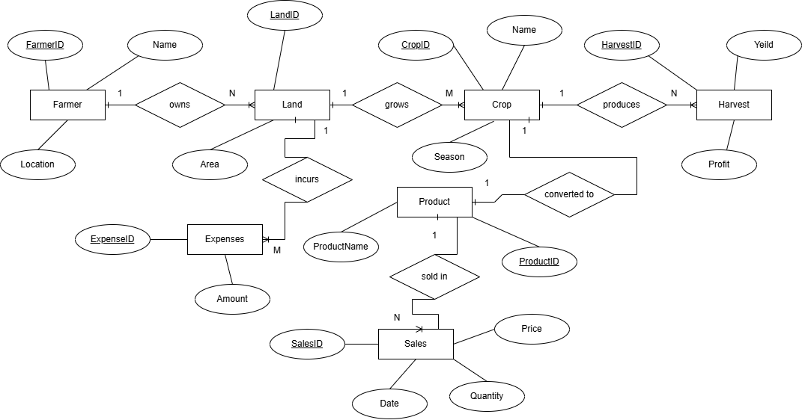

11. Advantages / Improvements
- Reduced Redundancy: Duplicate data is removed

- Better Organization: Data is stored in structured tables

- Faster Retrieval: Easy to search and access records

- Improved Integrity: Use of primary and foreign keys

- Easy Updates: Changes can be made efficiently

- Better Decision Making: Helps in tracking sales and profit

12. Conclusion
This case study helped us understand how data is managed in a real-world farmer-vendor system. We observed that manual record-keeping leads to issues like redundancy, lack of organization, and difficulty in data retrieval.
By applying DBMS concepts such as normalization and relational design, we converted unstructured data into a structured database system. This improves efficiency, accuracy, and ease of data management.
Overall, the case study helped bridge the gap between theoretical knowledge and practical application of database systems.

13. Photos (Geotagged):
Photo 1: Field Visit Location:

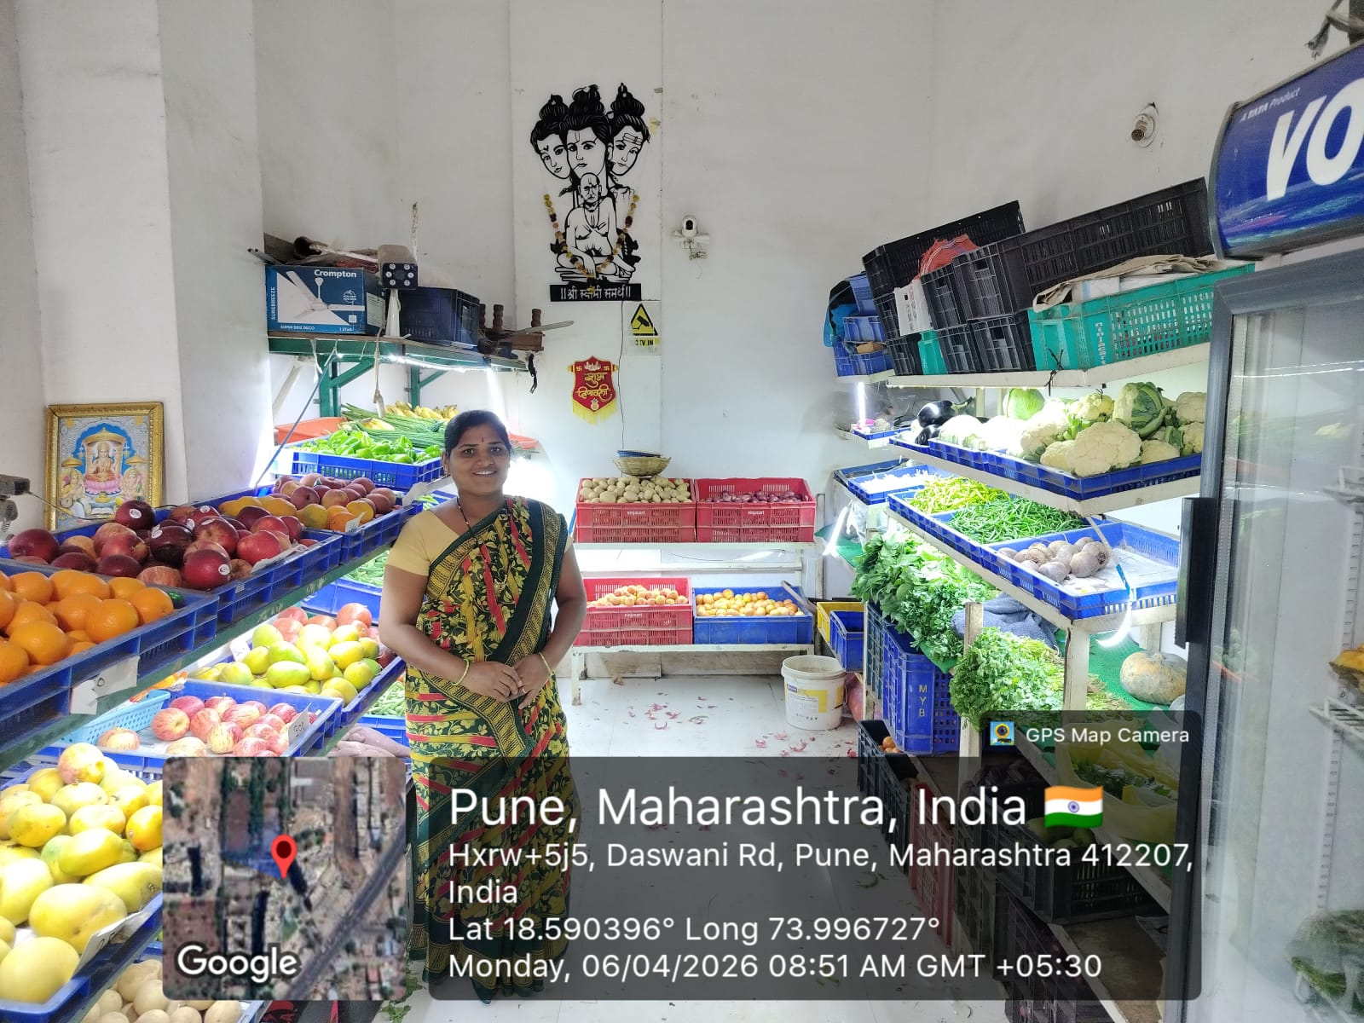

Description:
This image shows the vegetable shop where the field visit was conducted. It represents the working environment of the vendor who is also involved in farming activities.

Photo 2: Interaction with Vendor
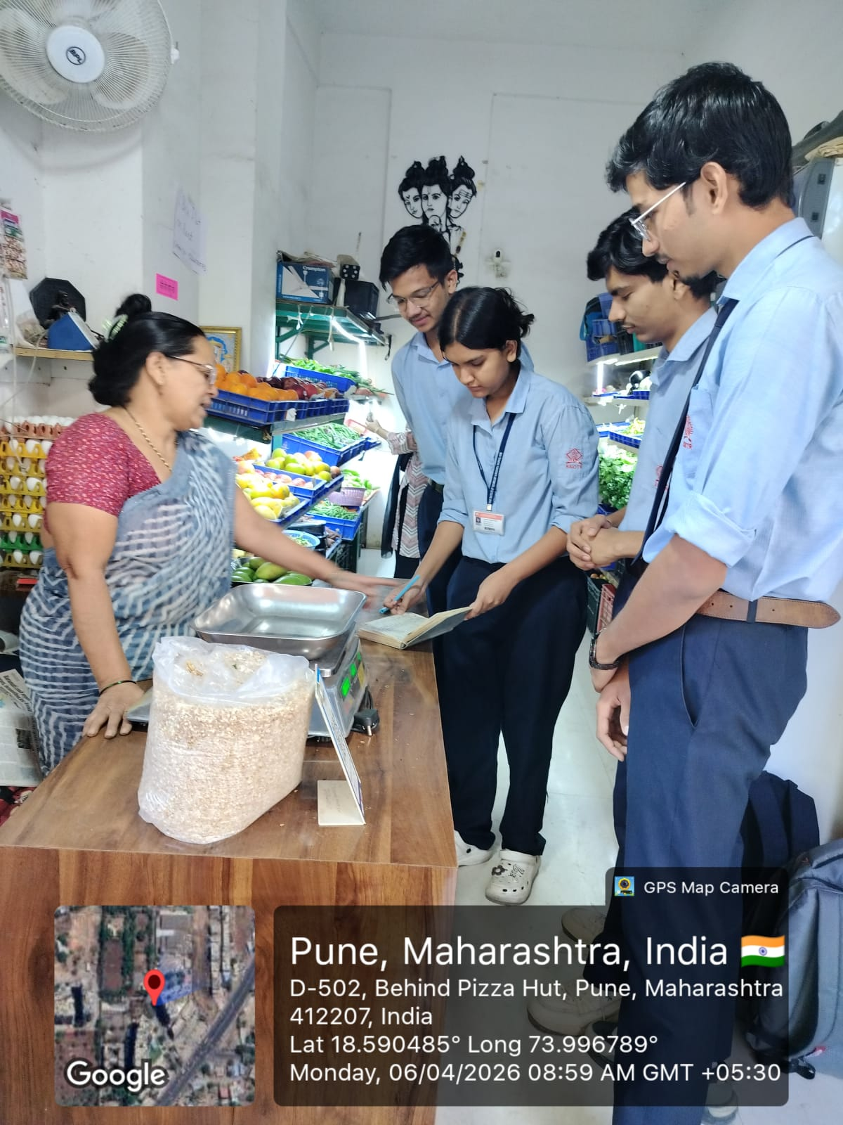
Description:
This image shows the interaction with Mrs. [Name], where we discussed record-keeping methods, pricing, and sales process.

Photo 3: Manual Record (Notebook)
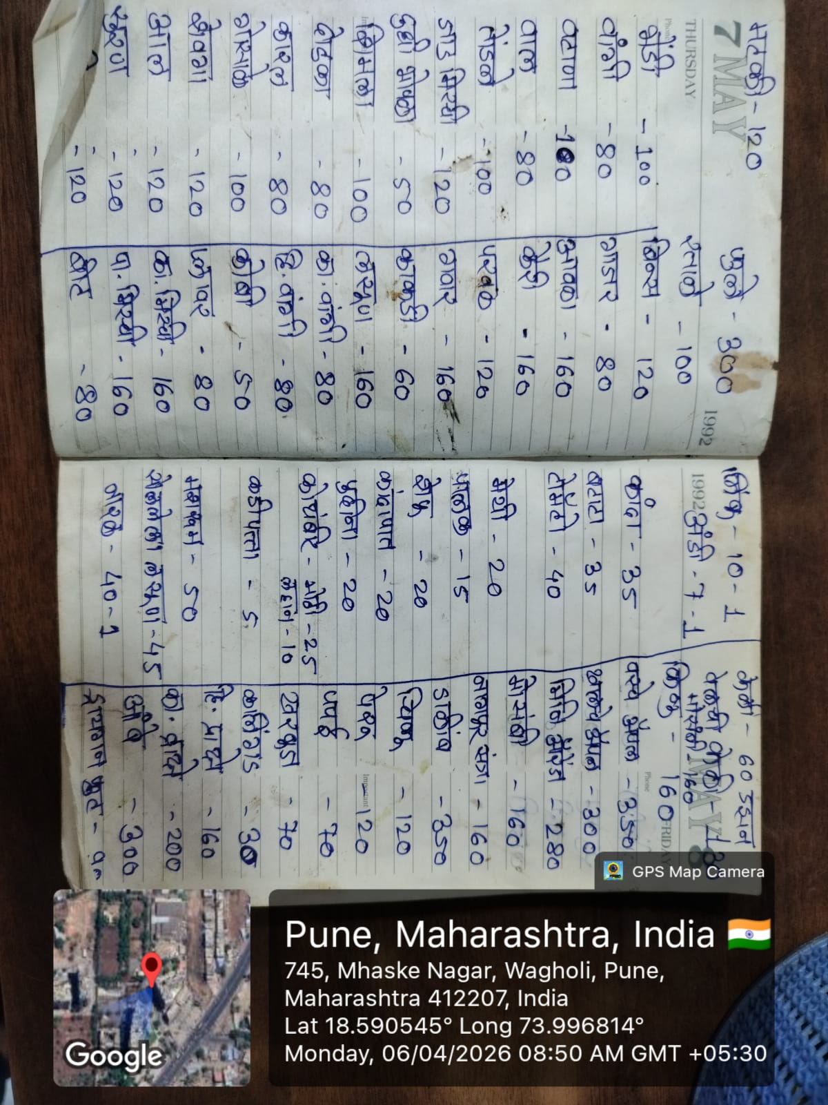
Description:
This image shows the manual notebook used by the vendor to record daily sales, prices, and quantities of vegetables.

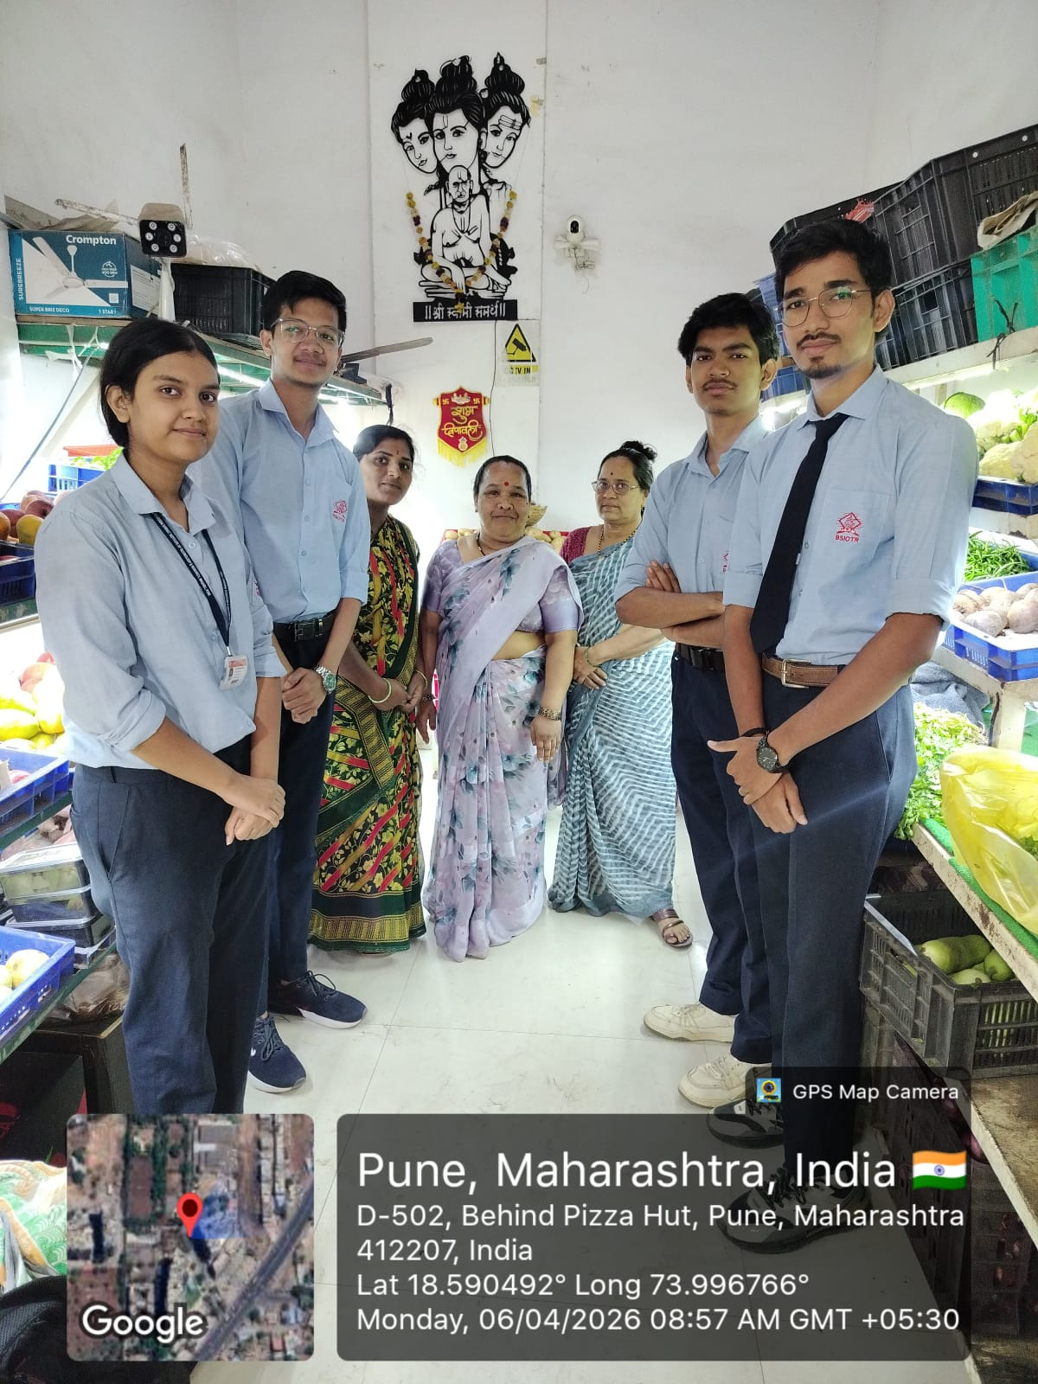
Photo 4: Group Visit

Description:
This image shows the group during the field visit, confirming participation and interaction with the vendor.

